1. Take year value as an input and create the folder for same name

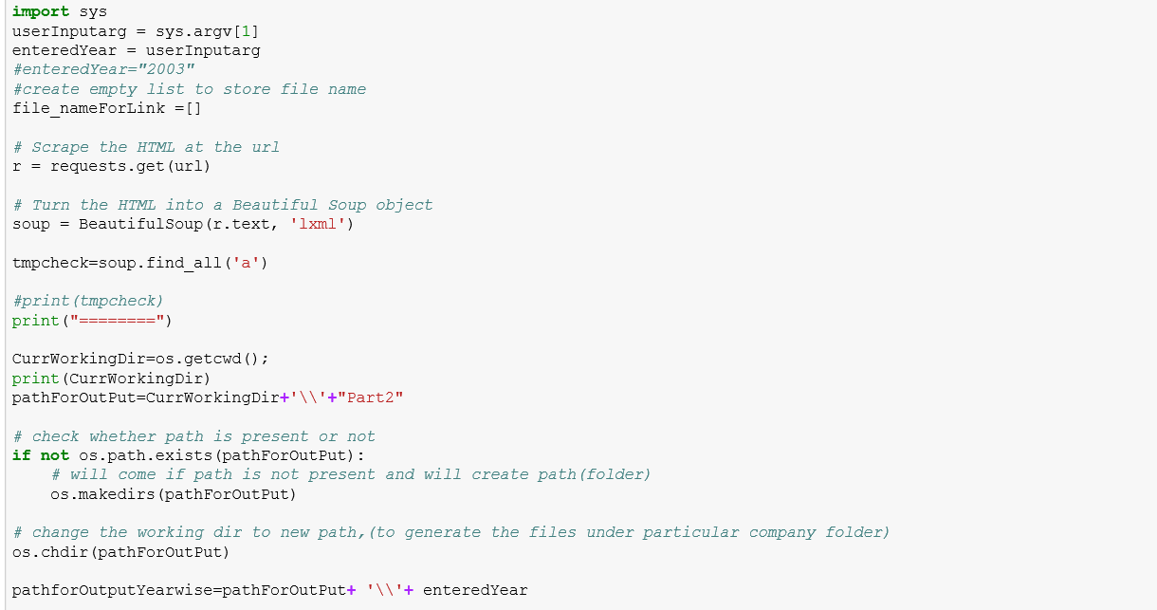

1. Create the required link for all the dates

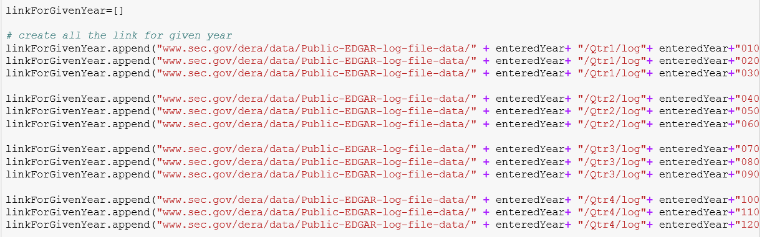

1. Loop through all the links and download the zip file and extra it on the same folder.

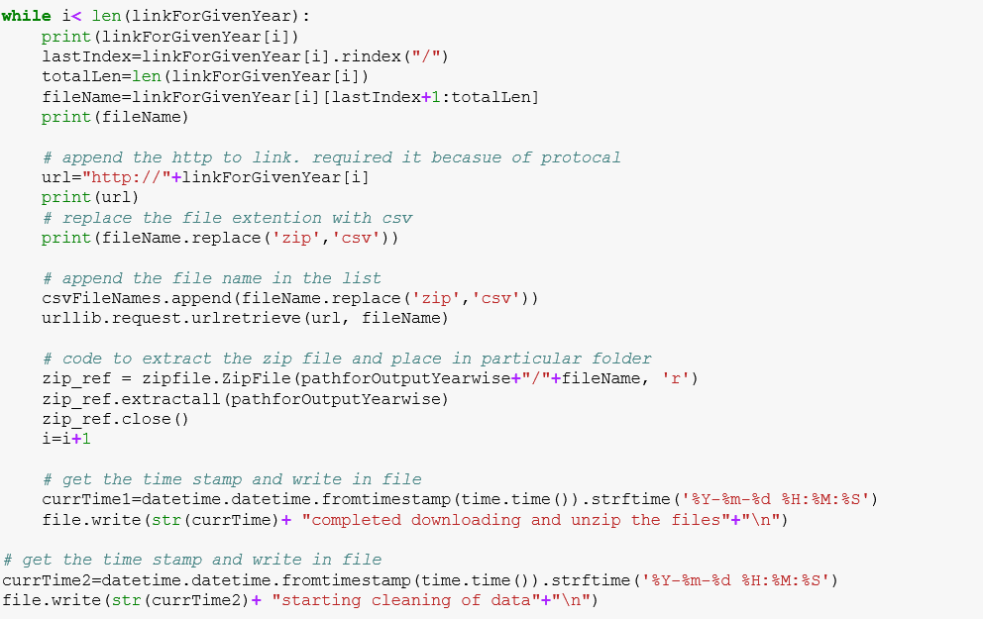

1. Loop through all the file and clean the data.

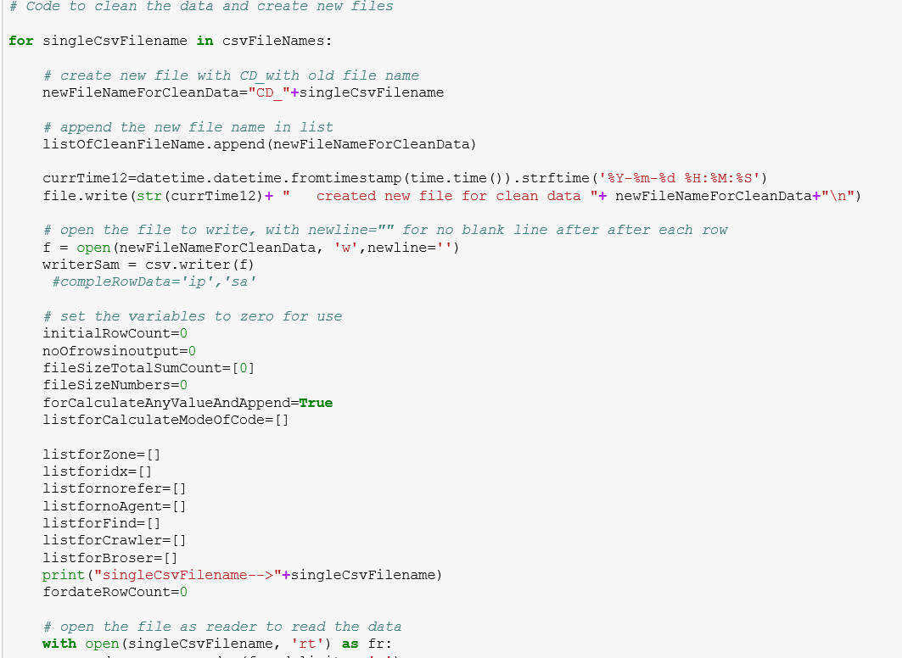

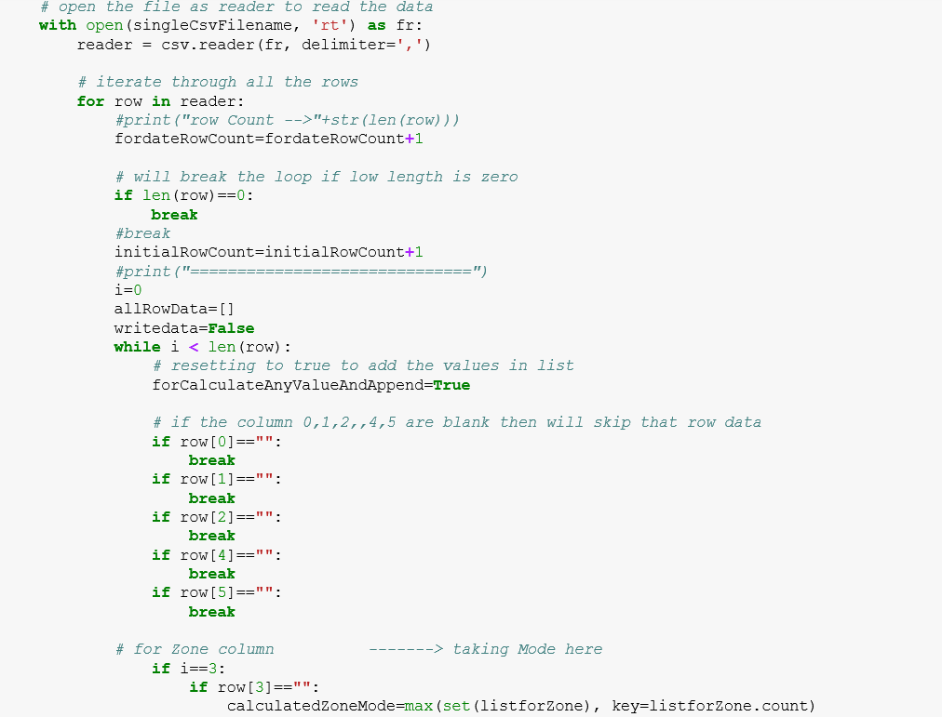

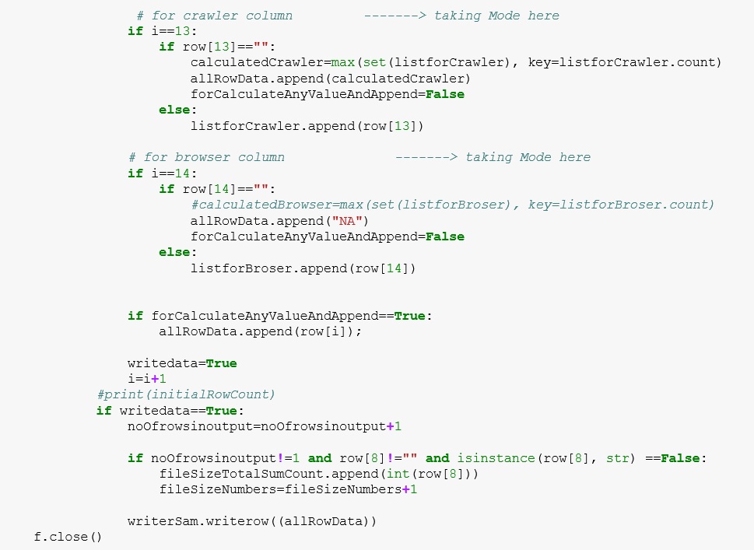

1. Take all the cleanup data file and combine them to one.

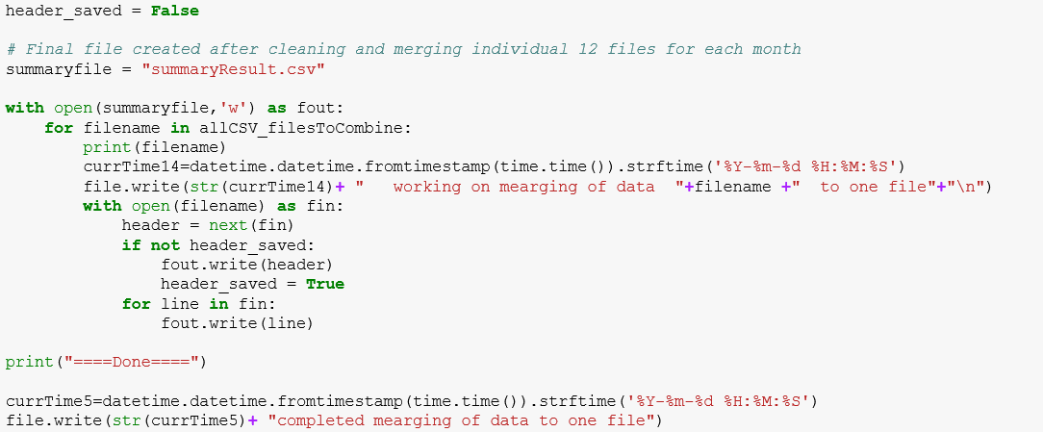

1. Make the Amazon S3 connection, create bucket and upload the file in bucket.

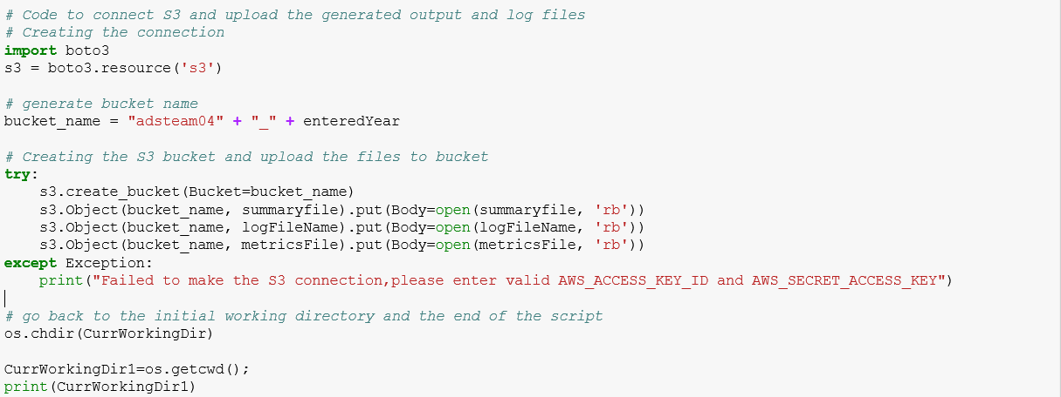

Used exception handling If amazon S3 credentials are not valid.